Guided Notes: Cell Membrane and Cell Transport

- Cell membrane is also known as ______________________________________.

- Cell membranes of unicellular organisms are ______________________________ so the organism can move.

- Cell membrane controls what ____________________________________ and leaves the cell.

- What does selectively permeable mean?

- A ____________________________ bilayer makes up most of the cell membrane.

- The ____________________ ______________________ _______________________ describes the appearance of the cell membrane.

- Are phospholipid heads polar or nonpolar?

- What is the phospholipid head made out of?

- Are phospholipid tails polar or nonpolar?

- What is the phospholipid tail made out of?

- What is the difference between hydrophobic and hydrophilic?

Hydrophobic –

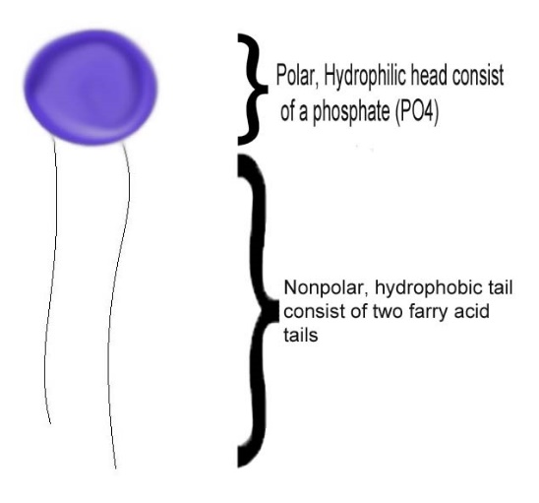
Hydrophilic –

- Label the following picture to the right using phospholipid head, tail, phosphate/glycerol, and fatty acid.

- What does homeostasis mean?

- Homeostasis is also called _________________________________.

- How does the plasma membrane help maintain homeostasis?

- Give 7 functions of the plasma membrane.
  - Protective _____________________________
  - Regulates _________________________________________________
  - Allows cell _____________________________
  - Provides _______________________________________ for filaments of the cytoskeleton
  - Provides a ______________________________________ for enzymes
  - ____________________________________________ bind cell together (_______________________)
  - Contains _______________________________________

- Sketch and label phospholipid bilayer.

- What are the other 2 components in a phospholipid bilayer?

- What do cholesterol and carbohydrates do?

- What do proteins do?
  - ________________________________ how particles pass
  - ________________________________
  - ________________________________

- Why is the cell membrane fluid?

- What causes the mosaic pattern of the cell membrane when viewed from above?

- The cell membrane is made of __________ layers of phospholipids call a lipid ____________________.

- __________________________ molecules pass easily, while ____________________________ molecules DO NOT.

- Materials soluble in __________________ can pass easily through the cell membrane.

- List 3 substances that pass easily through the cell membrane.

- ________________, _______________________ molecules larger than water, and large

_____________________ do NOT move easily through the phospholipids of the cell membrane.
Movement through the Membrane
- Two major types of movement occur through a cell membrane.
  - _____________________ transport b. ______________________ transport
    - ___________________________ i. ______________________________
    - ___________________________ ii. ______________________________
    - ___________________________
- Passive transport is when particles pass through a membrane _______________________ energy;

______________ to _____________ concentration.

- Name the 3 types of passive transport:
  - ___________________________ - movement of O₂, CO₂, and alcohol
  - ___________________________ - movement of water only
  - ___________________________ _______________________ - movement of larger molecules; needs a facilitator protein.
- Simple _______________________ requires NO energy to move things across the cell membrane.

- With simple diffusion, molecules move from an area of __________ concentration to an area of ______ concentration.
- Why is diffusion considered a passive process?

- With diffusion, molecules move by their own natural ___________________ energy or energy of motion.

- Explain what happens to a drop of food coloring put into a beaker of water.

- When solutes diffuse through a membrane, they move from ________________ to _____________ concentration.
- ________________ is the diffusion of _______________ across a cell membrane.
- If water potential is HIGH, solute concentration is __________.
- If water potential is LOW, solute concentration is ___________.
- An isotonic solution is when the concentration is the ___________________ inside and the ____________________ outside.
- Sketch a picture of a cell in an isotonic environment & show the direction of water movement.

- A hypertonic solution is a solution that has a _____________________ solute concentration than the cell.

- Sketch a picture of a cell in a hypertonic environment & show the direction of water movement.

- A hypotonic solution is a solution that has __________________ solute concentration than the cell.

- Sketch a picture of a cell in a hypotonic environment & show the direction of water movement.

- Complete the following table:

Direction of Osmosis
Environmental Condition | Net Movement of water | What happens to cell
Isotonic |  | Nothing
Hypotonic | Water Goes In
Hypertonic |  | Plasmolysis
- Explain what happens to a red blood cell placed in:
  - distilled water – cell swells and _________________________

  - a concentrated salt solution – cell shrinks and __________________

- _______________________________ occurs whenever water moves into the cells causing them to swell and burst.

- ________________________________ occurs whenever water moves out of a cell & the cell shrinks in size.

- Facilitated diffusion is the movement of specific molecules across cell membranes through _________________________________.

- Facilitated diffusion needs a ____________________________________.

- _______________________ ___________________________ is when particles pass through a cell membrane WITH energy, but go from __________________ to _________________ concentration.

- Active transport uses cellular energy known as _____________________.

- Moves ______________________________ the concentration gradient.

- The _______________________________________________ pump is an example of active transport.

- Moving very large particles out of the cell is called __________________________________.

- In exocytosis, wastes are moved out of the cell in _________________________ that fuse with the cell membrane.

- ________________________________ involves moving large particles into the cell.

- Taking in large liquid droplets is called __________________________________ or "cell drinking".

- _________________________ _______________________ endocytosis involves protein ____________ recognizing hormones to help move them into the cell.

- "Cell eating" is known as _______________________________________.

