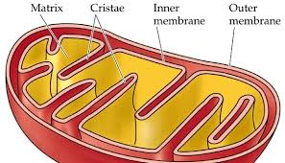

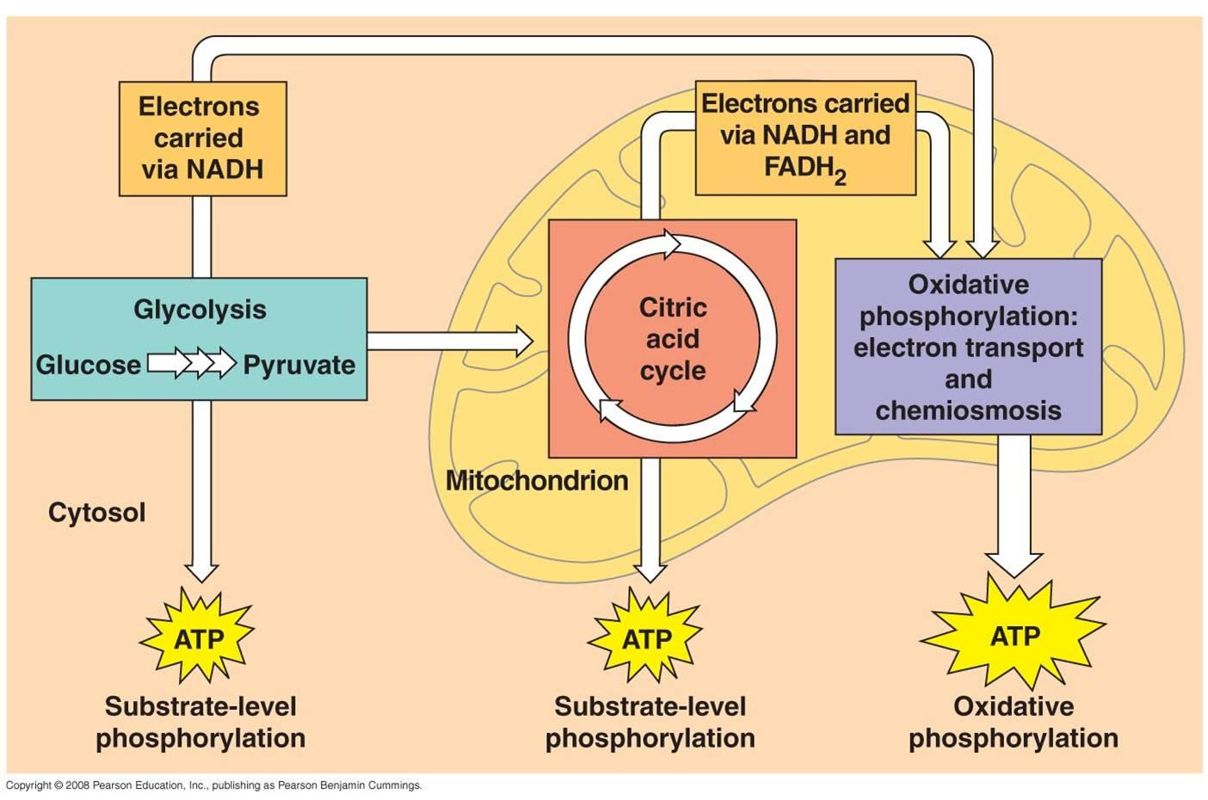

|  |  |  |
| --- | --- | --- |
| Glycolysis | Krebs Cycle | Electron Transport Chain (ETC) |
|  |  |  |