Name: Class Period:

Fantastic Beast Genetics Workshop

- Incomplete Dominance: Groots are a tree-like species (Flora colossus) from the Planet X. Every few years, Groots reproduce – like other plants, Groots produce flowers. Flower color is governed by incomplete dominance; RR produce red flowers, WW produce white flowers, while RW produces pink flowers.
  - Two pink flowered Groots are crossed. What was the genotypic and phenotypic ratios of their offspring?

  - If the 2 pink flowered Groots produce 500 offspring, how many of them should have red flowers? Explain your answer and show your work.

    - Codominance: Diricrawls are plump, fluffy-feathered, flightless birds. Feather color is co-dominant; F^{A}F^{A} have pink feathers, F^{B}F^{B} have purple feathers and mottled diriclaws (F^{A}F^{B}) have both pink and purple feathers. Pink feathered diricrawls are very rare and prized by collectors. If you breed 2 mottled diricrawls, what percentage of their offspring will be pink feathered? (show all of your work and use a Punnett square).
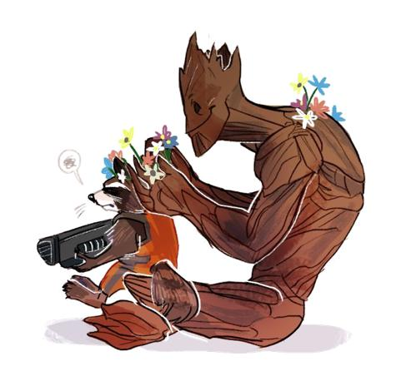
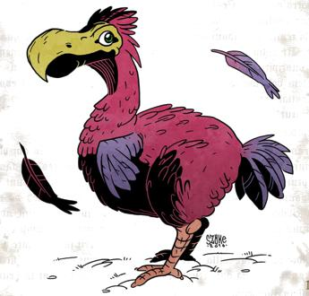

Name: Class Period:

- Blood types: House elves have the same basic blood types that human have; A,B, AB and O.

  - If a male house elf with blood type O has children with a female house elf who is blood type AB, what will the phenotypic ratios of their offspring be? (show your work).

  - A male house elf with blood type A (but whose mother was blood type O) has children with a female elf who is type B (whose mother was type A and whose father was type AB). What percentage of their offspring should be blood type B?

  - Dobby is blood type A and Harry Potter is blood type AB. Is it possible for Dobby to give blood to his master? Can Harry give blood to Dobby? Explain.

    - Pedigree: Graphorns are dragon-like creature native to Europe. They’re prized for their skin which is thicker than a dragon’s. However, the other form of their skin is thin and scaly. Use the pedigree below to answer the following question – thick skinned Graphorns are indicated with a solid symbol:
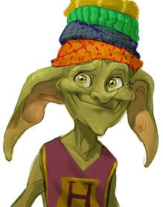
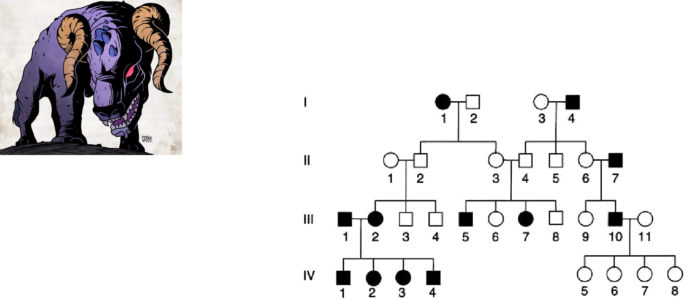

- What is the genotype of I,4?

- What is the genotype of II,6?

- What is the genotype of II,2?

- Is solid skin dominant or recessive? Us specific references to the pedigree to support your answer.

Name: Class Period:

- Sex-linked: Presence of horns in erumpents is a sex-linked trait; presence of horns is dominant while the absence of horns is recessive.
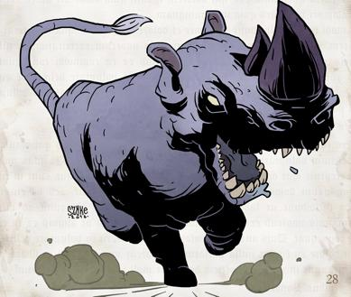

- Of the male offspring, what percentage of them should be hornless? Use a Punnett square to support your answer.

  - Cross #2: A hornless male erumpent was crossed with a horned female (but whose father was hornless). What is the probability of getting 3 female erumpents with horns? Use a Punnett square to support your answer.

- Hagrid has been breeding his pets again. He is breeding his pet Fluffy (a large 3-headed, slobbering dog) in an attempt to get 4 headed drooling dogs. Hagrid knows that having 3 heads is dominant (H), while the presence of 4 heads is the result of a recessive allele (h). Drooling is a dominant trait (D), while dry mouth is a recessive trait (d). What is the expected frequency of drooling, 4-headed dogs in if Hagrid crosses 2 dogs that are heterozygous for both traits?
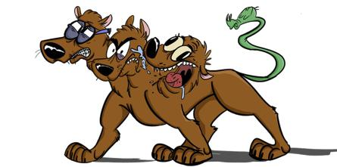

Name: Class Period:

- Challenge Question: color in eumpents is incompletely dominant; black color (BB), white color (WW) or grey (BW). Remember that presence or absence of horns is sex-linked. What is the probability of getting a grey, horned erumpent of either sex from the following cross:

X^{H}Y BW crossed with X^{H}X^{h} BW
