Meiosis and Fertilization Computer Lab!!!!!
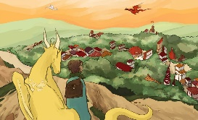
1st Activity: Write down the chosen female and male traits. One allele for each chromatid.
Mother Father

2nd Activity. Choose one parent from the parent pool. Then hover over the chromatids. Draw and write thee traits you see before and after ______________ has taken place. Can you guess what the blank is?
Parent chosen:
Before After

Challenge 1: Match the chromosomes from father and mother to create the two offsprings as seen on lab.
When an egg and sperm meet, they produce _________________. This is done doing what process? _______________________

What traits do the mother carry? Hover over chromatids.

What traits do the father carry? Hover over chromatids.

Challenge 2: Pick the mommy.
Explain how you picked the mommy. Talk about traits and process of elimination or draw a Punnett square.

Challenge 3: Mix & Match
What were you able to do when you pressed swap?
This is known as what_________________________. When you did it correctly it told you the word.
Note what you crossed over with each parent and the end results for the offsprings.

