NATURAL SELECTION—GUIDED NOTES
EVOLUTIONARY IDEAS
- Although Darwin is given much credit for evolutionary theory, he was not the first person to come up with the idea.
- Evolution is the ____________________________________________________________ by which descendants come to _______________ from their ancestors.
  - The concept of evolution had been discussed for more than 100 years prior to Darwin’s theory.
    - Evolution is the central theme in all fields of biology.
Carolus Linnaeus
- Botanist (1700s)
- Developed a _______________ system for all known organisms (at the time).
  - Organisms are together based on their similarities.
    - Groupings in his classification system reflects evolutionary relationships.
Jean-Baptiste Lamarck
- French Naturalist (1809)
- Stated that all organisms evolve toward _______________ and complexity.
- He did not think that species became extinct, only evolved into different forms.
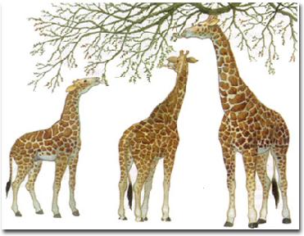
The Inheritance of Acquired Characteristics
- Larmark proposed that changes in an organism’s _______________ caused an organism’s _______________ to change, leading to greater ______________________________ of a structure or organ.
- This structure would become larger or smaller as a result, and these changes would be passed onto the organism’s offspring.
- This theory is ultimately _______________.

CHARLES DARWIN
- In 1831, he took off on the HMS Beagle, and would explore the world (including the Galapagos Islands) for 5 years.
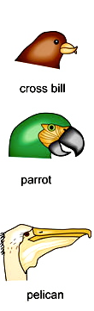
  - He collected numerous species and took meticulous notes. He would then send them to experts for analysis.
Variations
- Variation is the _______________ in the ______________________________ of an individual from those of other individuals in the group to which it belongs.
- Interspecific variation
  - Occurs among members of _______________ species.
- Intraspecific variation
  - Occurs among individuals of the _______________ species.
Island Variations
- Darwin noted that the species found on one island looked different from those on nearby islands.
  - Ex. Areas with large, hard-shelled nuts, often had finches with strong, thick beaks. Conversely, areas with many insects and fruits, had finches with more delicate beaks.
Adaptation
- Darwin realized that species must be able to _______________ to their _______________, and that those adaptations could _______________ a _______________ change in a population over time.
  - An adaptation is a _______________ that allows an organism to ______________________________ in its environment.
Fossil Evidence
- Darwin also found ______________________________ of species changing over time.
- Ex. He found the fossils of Glyptodon, a giant armadillo. He hypothesized that it was related, in some way, to the modern armadillo.

The Oldest Living Tortoise
- Darwin collected three Galapagos tortoises from the islands, and brought them home. He named them Tom, Dick, and Harry, thinking that all were male.

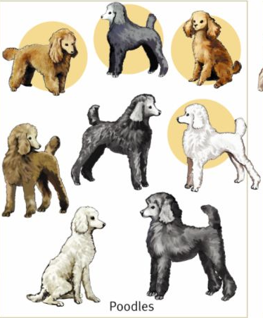
Artificial Selection
- Artificial selection is the _______________ by which ______________________________ a _______________ by breeding it for certain traits.
  - Humans determine which trait is favorable and then breed individuals that show those traits.
    - Darwin began to breed pigeons to understand artificial selection.
- Darwin compared what he learned from breeding pigeons to his ideas on adaptation.
  - In artificial selection, features such as reversed neck feathers, large crops, or extra tail feathers are selected over generations because breeders like these particular traits.
  - If a feature is not desirable, or “useful”, it would be selected against.
Natural Selection
- Natural selection is a _______________ by which _______________ that have inherited _______________ adaptations produce ______________________________ on average than do other individuals.
  - In nature, the _______________ is the selective agent.
    - Therefore, characteristics are selected only if they give advantages to individuals in the environment.
Struggle for Survival
- An English economist, Thomas Malthus, had proposed that resources such as food, water, and shelter were natural limits to population growth.
  - Darwin reasoned that this struggle took place in nature, _______________ were _______________, and organisms had ______________________________ than could ever _______________.
    - Those individuals best suited to their environment would survive and breed.
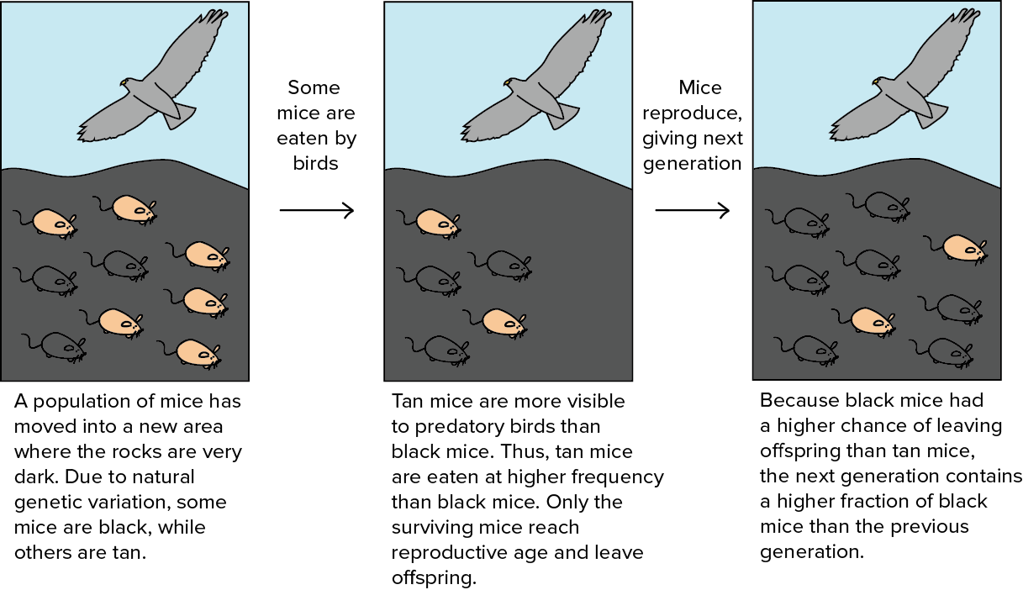

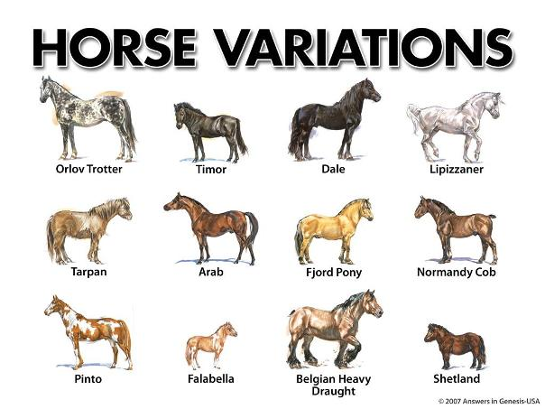
EVIDENCE FOR NATURAL SELECTION
- There are four main principles to the theory of natural selection:
  - ______________________________
  - ______________________________
  - ______________________________
  - ______________________________
Variation
- The differences among individuals result from differences in the genetic material of the organisms, whether ___________________ from a parent or resulting from a genetic ____________________.
Adaptation
- Sometimes, a certain ___________________ allows an individual to survive better than other individuals it competes against in its environment.
  - More _________________ individuals are “naturally selected” to live _______________ and to produce _______________ offspring that share those adaptations for their environment.
Descent with Modification
- Over time, ___________________________________________, will result in species with ______________________________ that are _________________ suited for ______________________ and _________________________ in an environment.
  - More individuals will have the trait in every following generation, as long as the environmental conditions continue to remain beneficial for that trait.
Fitness
- Fitness is a measure of the ___________________ to _____________________ and produce _____________ offspring relative to other members of the population in a given environment.
  - After the climate change, jaguars that had larger teeth and jaws had a higher fitness than other jaguars in the populations.

THE EARTH’S HISTORY
Geologic Change
- The age of the Earth was a key issue in the early debates over evolution.
  - The common view was that the Earth was 6000 years old.
  - Many scientists argued that the world had to be _______________ based on geologic changes (_______________), and the _______________ found within them.
Catastrophism
- The theory that _____________________________________________, such as floods and volcanic eruptions have happened often during Earth’s history.
  - These events shaped landforms and caused __________________ to become extinct in the process.
Gradualism
- The theory that landforms resulted from ______________ ___________________ over long periods of time.
  - The laying down of soil or the creation of canyons by rivers cutting through rock were not the result of large-scale events, but rather resulted from slow processes that had happened in the past.
Uniformitarianism
- This theory states that the geologic processes that shape Earth are ______________________ (constant) through time.
  - It proposes that both ______________________________ AND ______________________________ (i.e. wind, rain, current, etc) shaped the Earth, these changes have occurred at a constant rate and are ongoing.
Transitional fossils
- Many transitional forms have been discovered between species.
  - The fossil record today includes many thousands of species that show the ______________________________ over time.
    - The mix of traits in transitional species often makes it difficult to tell where one species ends and another begins.
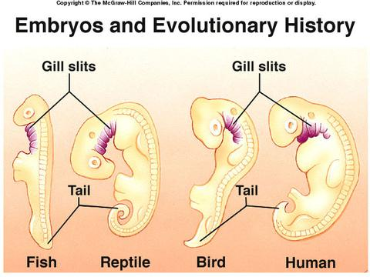
Embryology
- If you look at the larvae of a crab and a barnacle, they both swim and look alike, but the adult animals look and behave very differently.
- Embryos of vertebrates can also be very hard to tell apart.
  - Birds, fish, reptiles, and mammals all have gill slits and tails as embryos.
    - Such similar features in different organisms embryos suggests _______________________ from a distant ___________________ ancestor.

Homologous Structures
Features that have __________________ ___________________ but __________________ __________________
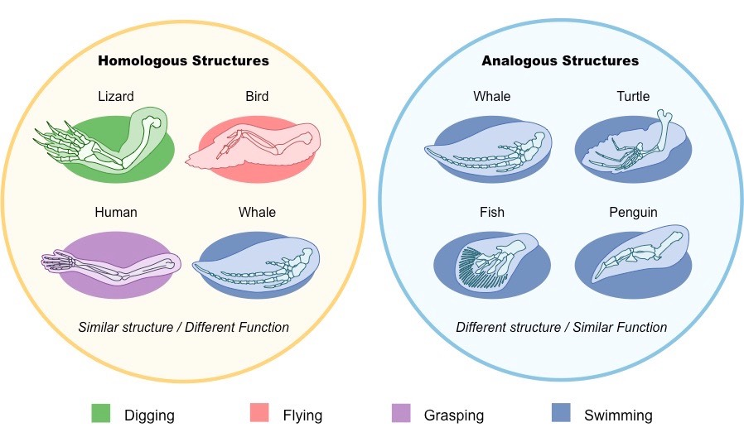
  - Their appearance across different species offers strong evidence for common___________.
- Forelimb anatomy
  - The forelimbs of humans, cats, whales and bats have several bones that are very _________________ to each other despite their different functions.
Analogous Structures
- Some structures found in different species have the same function, but ________________ evolve from a common ancestor.
  - For example, two organisms need to be able to fly. Both can develop similar adaptations using different body parts, like the wings of bats and the wings of flying insects.
- Features that have the _____________________ function but ____________________________ structures.
  - The similar function of wings in bats and flying insects evolved separately. Their ancestors faced similar environmental challenges and came upon similar solutions.
Vestigial Structures
- Some organisms have structures that seem to lack any useful function, or at least are no longer used for their original purpose.
  - For example: snakes have tiny pelvic bones and stump-like limb bones, even though snakes don’t walk.
- Vestigial structures once had a __________________ but ______________________________ do.
- Appendix
  - The appendix is a remnant of the large intestine in plant-eating animals. It helps to digest cellulose.
  - In humans, we don’t eat much cellulose, and the appendix performs a very limited function.

